**Ball Bounce 2d**

Name:

Hamza Saif (FA18-BSE-096)

Abdur-Rehman (FA18-BSE-075)

Section: “A”

# Document the primary gameplay mode of your project:

The game has a ball character and different obstacles. There are square shape villains to in the game which will try to affect and stop the ball from passing the particular level. The game should have different levels and the difficulty of the game increases with each level.

The ball should be able to move through different type of obstacles in order to pass the level. The ball will have three lives for each level.

# Write the model that you are using:

We are using scrum agile process model for the project.

# UI of the game:

## Menu of the game:



## Game Mode (Level 1) :

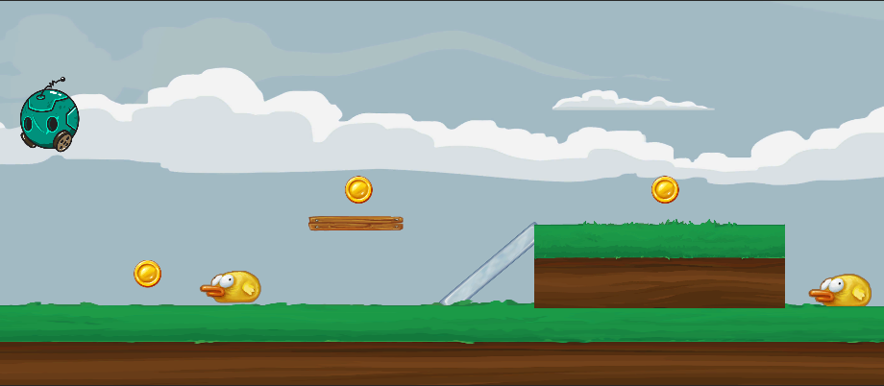

## Game Mode (Level 2) :

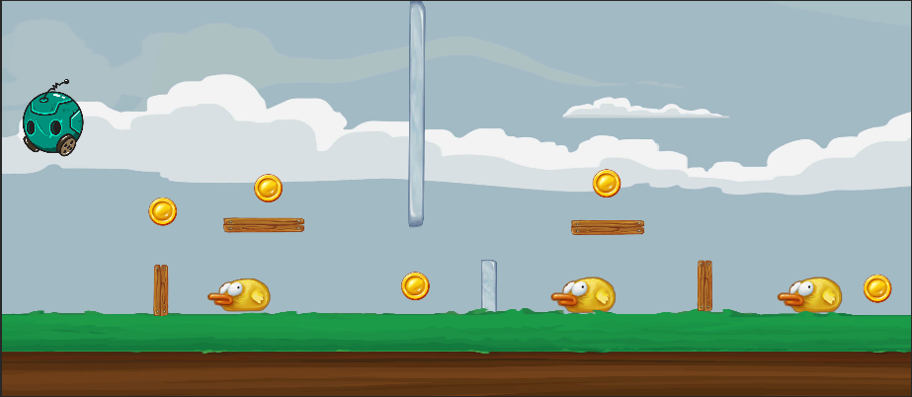

The ball should be able to move through different type of obstacles in order to pass the level. The game should have different levels and the difficulty of the game increases with each level.